Topic 1: WORK, ENERGY AND POWER
Objectives:
At the end of this class, students should be able to:
- Define work, energy and power.
- Calculate work done
- Calculate energy and power
- Show inter-changeability of work and power.
CONTENT
WORK:
- Work is done when a force moves a body through a distance in the direction in the direction of the force.
- A stationary boy carrying a bucket of water on his head is not doing any work because motion is not involved.
- Work is mathematically defined as the product of force and distance in the direction of the force.
i.e. Work = Force $×$ Distance
- It is a scalar quantity
- Its derived S.I units is Joules (J).
- Its basic S.I unit is Kg$m^{2}s^{-2}$.
- Whenever work is done, certain amount of energy is transferred.
Example:
- A force of 50N is applied on a body of mass 100g. if displaces the body through 5m, calculate the workdone by the force.
SOLUTION:
F= 50N
m= 100g = 0.1kg
s= 5m
W= F$×S$
= 50 $×5$
= 250J
- A force of 20N is applied on an object as shown below. If the body slides along the horizontal plane through a distance of 3m. calculate the work done by the force.

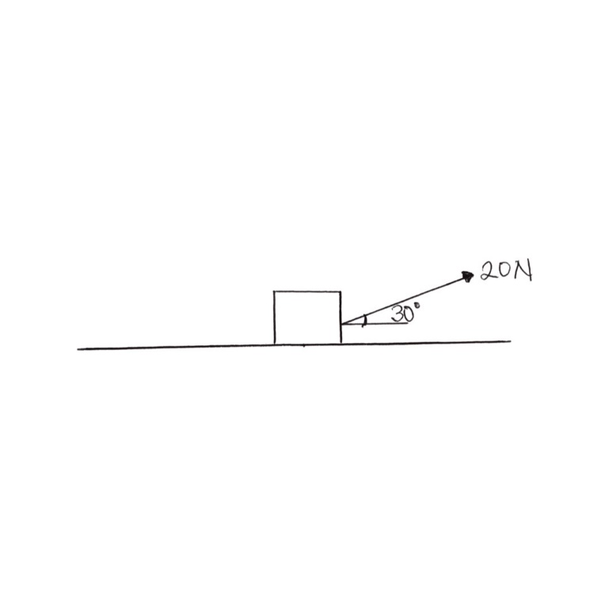

F= 20N
S= 3m
Component of F in the direction of motion= 20cos30
W= 20cos30 $×3$
= 51.96J
ENERGY
- This is the ability to do work
- It is a scalar quantity.
- It S.I unit is also Joules (J)
- It exists in different forms such as
- Mechanical energy
- Heat energy
- Chemical energy
- Electrical energy
- Solar energy
- Radiant energy
- Nuclear energy etc.
- These energies can be changed from one form to another and this is noticeable in the appliances we use at home.
- Principle of conservation of energy says “Energy can neither be created nor destroy but can be changed from one form to another”.
- Mechanical energy as a case study exist in two different forms
- Potential energy: is the energy a body has by virtue of its position. Potential energy of a body associated with gravity changes with height of the body and it is given as
${P.E}_{gravity}$=mgh
$${P.E}_{gravity}=gravitational potential energy$$
M= mass of the body
g= acceleration of free fall due to gravity
h= height of the object
- There are other kinds of potential energy such as elastic potential energy.
On the other hand;
- Kinetic energy: is the energy of a body by virtue of its motion. Kinetic energy depends solely on the speed with which the body moves and it is given by
K.E = $\frac{1}{2}mv^{2}$
K.E= Kinetic energy
m= mass of the body
v= speed
- When a body moves from one position to another position of different height, there is a transition between Kinetic and Potential Energy.
- Work must be done to change the speed of the moving body which result in change in the kinetic energy of the body.
Thus, Work done = change in K.E
W = $\frac{1}{2}mv^{2}$ $-\frac{1}{2}mu^{2}$
= $\frac{1}{2}m(v^{2}-u^{2})$
- Work must also be done to move a body from one height to another thereby changing the potential energy of the body.
Thus, Work done = change in P.E
W = mgH – mgh
W= mg (H- h)
EXAMPLES:
- A body of mass 10kg is released from a platform of height 20m. Calculate
  - Potential energy of the body at the platform.
  - Kinetic energy of the body at the platform
  - Potential energy just before striking the ground.
  - Kinetic energy just before striking the ground.
  - The speed with which it strikes the ground.
(Take g=10m/$s^{2}$)
SOLUTION:
m=10kg g=10m/$s^{2}$
- When the body is at the platform, h=20m
P.E. = mgh
= $10×10×20$
= 2000J
- At the platform, there was no motion; V=0
K.E = $\frac{1}{2}mv^{2}$
= $\frac{1}{2}(10){(0)}^{2}$
= 0
- Just before striking the ground, h = 0
P.E= 0
- At the point of striking the ground, all the P.E has been converted to K.E
i.e. K.E = 2000J

- K.E = $\frac{1}{2}mv^{2}$
2000 = $\frac{1}{2}(10){(v)}^{2}$
5$v^{2}=2000$
$$v^{2}=\frac{2000}{5}=400$$
v= $\sqrt{400}$
v= 20m/s
POWER
- This is the rate at which work is done. The rate at which energy is used up by a device.
- It is mathematically expressed as;
Power = $\frac{workdone}{time}$
- Its S.I unit is Watts (W)
- It is also measured horse power (hp)
- 1 hp = 746W
- P =$\frac{F×S}{t}$
P = F $×\frac{s}{t}$
P = F $×V$
- The power of the engine of vehicles is expressed as
Power = thrust $×speed$
= force $×speed$
- It is a scalar quantity also.

